**Course Description**

This two morning or one day advanced course will develop your skills of using spatial data, including collating data from a variety of sources including XY coordinate data and address or postcode based data. We will also cover using spatial overlays, point-in-polygon analysis and spatial joins.

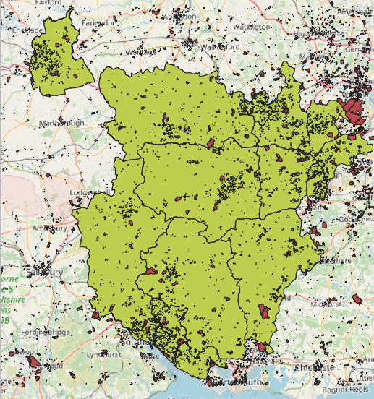This course is ideal for anyone who wishes to build on their existing spatial data and GIS knowledge. It gives you the skills to answer questions using your data, and understand the advantages and limitations of this type of spatial data analysis. It is also suitable for those who wish to have an overview of what GIS analysis can do and what it can be used for.

*This course can follow-on from the Introduction to QGIS: Understanding & Presenting Spatial Data course, or be run independently if the participants have some previous knowledge of QGIS and spatial data.*

**Learning Outcomes**

* Be able to locate and open a range of GIS data sets
* Understand how to import, join and make use of postcode and XY coordinate based data
* Know how to apply GIS analysis tools, including spatial overlays, point-in-polygon and spatial joins.
* Know other GIS analysis tools and how they work
* Be confident at applying the skills to their own data

Greenspace polygons

Local Authority polygons

Union

Dissolve

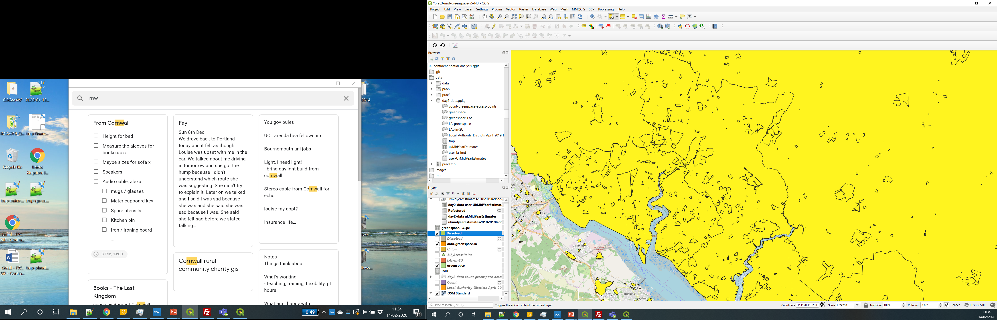

**Outline: Day 1**

* 10:00am - 10:45am – Recap of GIS
* 10:45am - 11:00am – Finding & using data
* 11:00am - 11:30am – Joining data
* 11:45am - 12:30pm – Greenspace points

**Outline: Day 2**

* 10:00am – 10:30am – Recap and practical
* 10:30am – 10:45am – Spatial overlays
* 10:45am – 12:15pm – Overlay practical
* 12:15pm – 1:00pm - Your own data

*"MANY thanks Nick. Outstanding material!"*

*"A very well run course. Good content, good pace,   
interesting lectures/examples and an enthusiastic teacher."*

Have a look at [www.nickbearman.com](http://www.nickbearman.com) or contact me for more details

Dr Nick Bearman | +44 (0) 7717 745715 | [nick@nickbearman.com](mailto:nick@nickbearman.com)